## E-DIRECTIVES

The e-Directives tab provides information from a linked e-Directive Registry, including advance directive forms, DNR (do not resuscitate) cards, and POST (Physicians Orders for Scope of Treatment) forms. To view a document, click on the link.

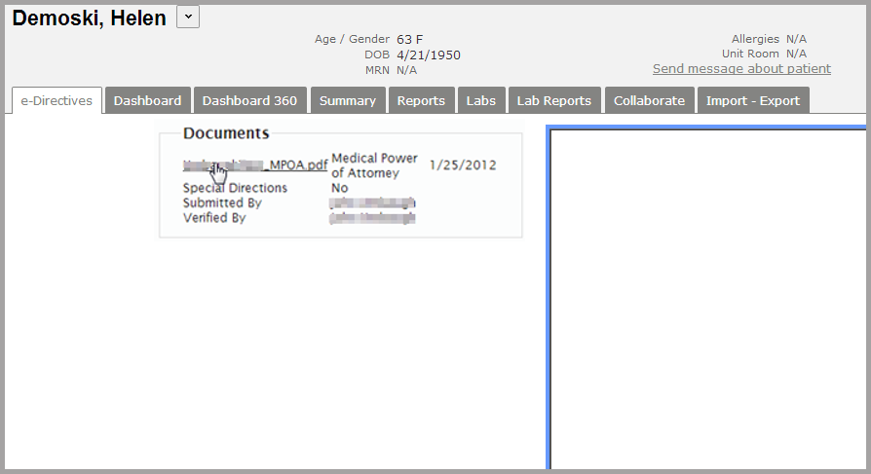

The document will display in the frame to the right of the Documents list.

